**Ayushmaan Bharath ( National Health Protection Scheme)**

***(Proof Of Concept)***

**Tasks to be done from backend:**

**-** Registeringpatient information into Ropsten TestNet. ( In our case: Patient ID, Max Claim

Amount, Amount claimed and Number of claims).

- Will on board providers and negotiation percentage into TestNet.

- Can change the parameters like state govt percentage, central govt percentage

- Adding ICD codes and corresponding prices.

**Workflow from Home Page as follows:**

- We have designed this PoC in a Patient centric mannar.

- The main stakeholders are HealthCareCenter user, Central Government, State Government and

Patient.

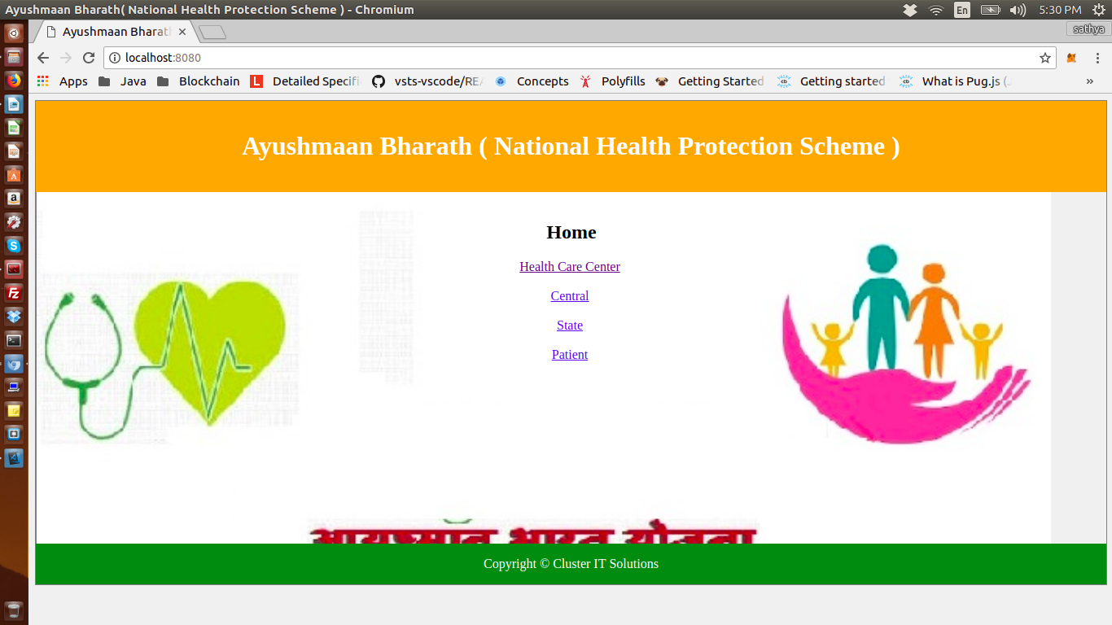

**Stakeholders and their actions:**

**Health Care Center:**

- This user will have permission to create a claim, view the patient details and the claim details.

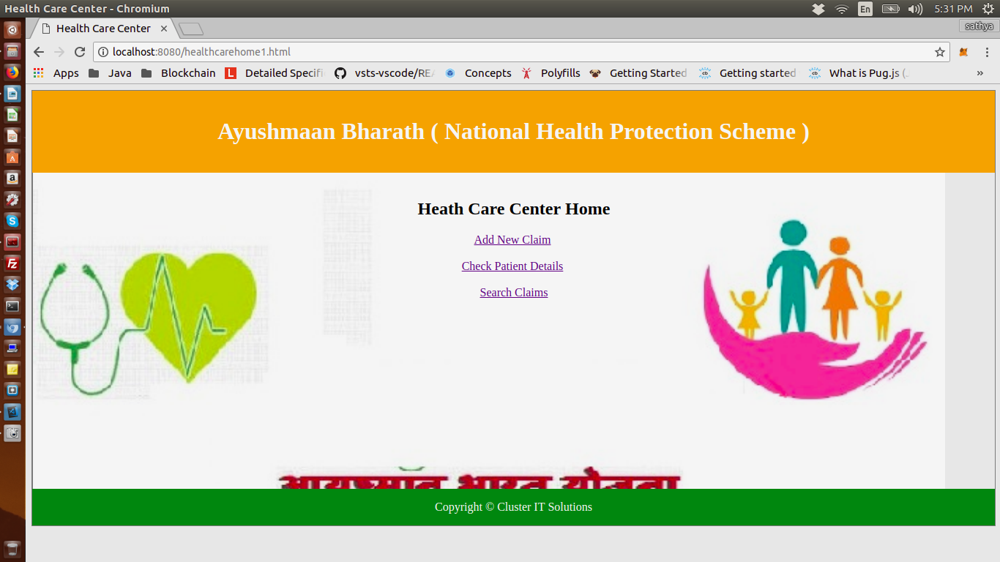

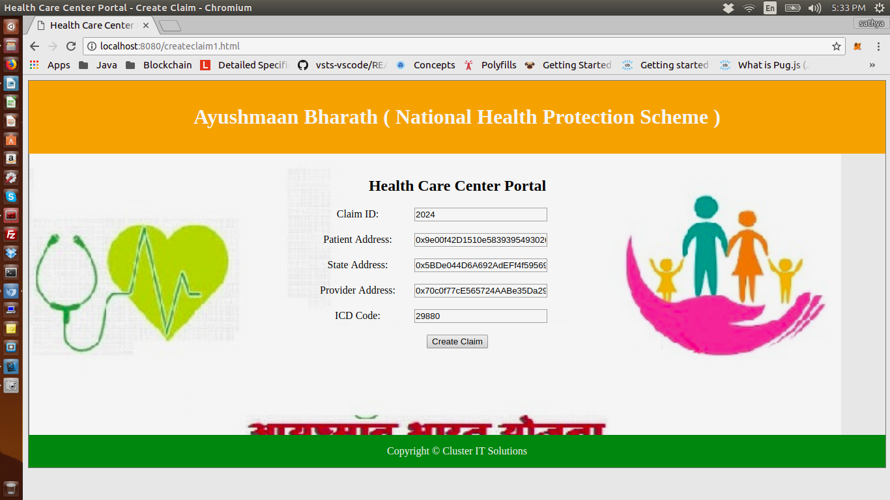

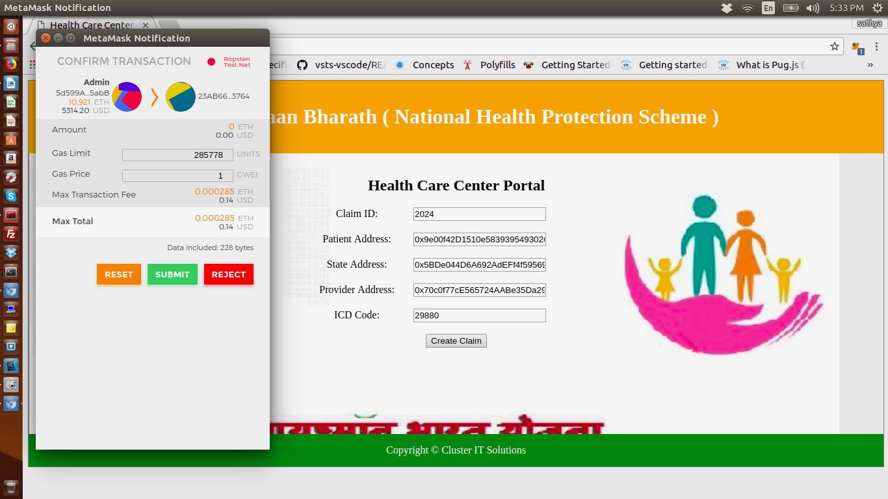

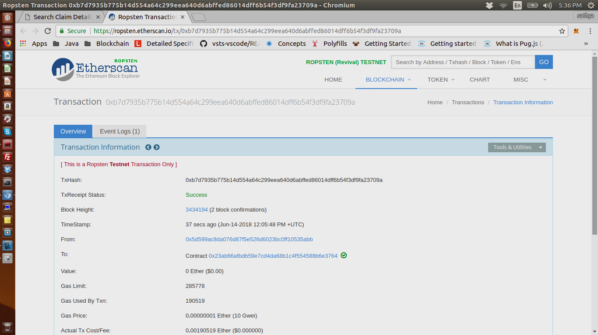

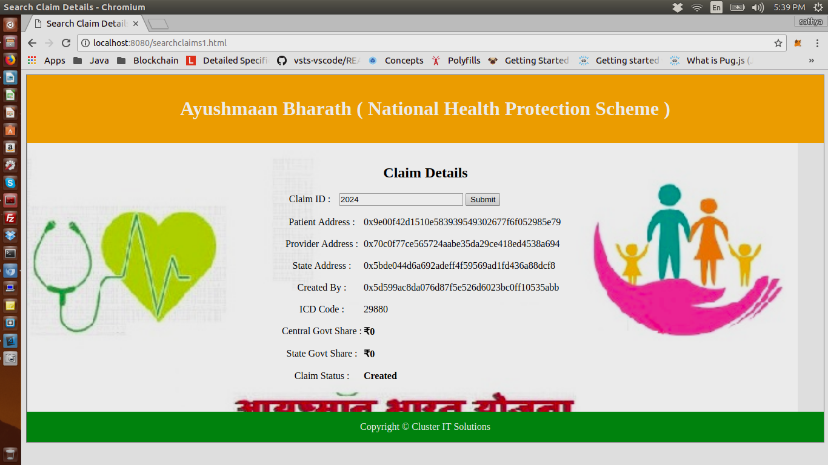

**Central Government:**

- This user can view all the claims logged in all the states and filter them by state.

- Also view the claim details and the total central share.

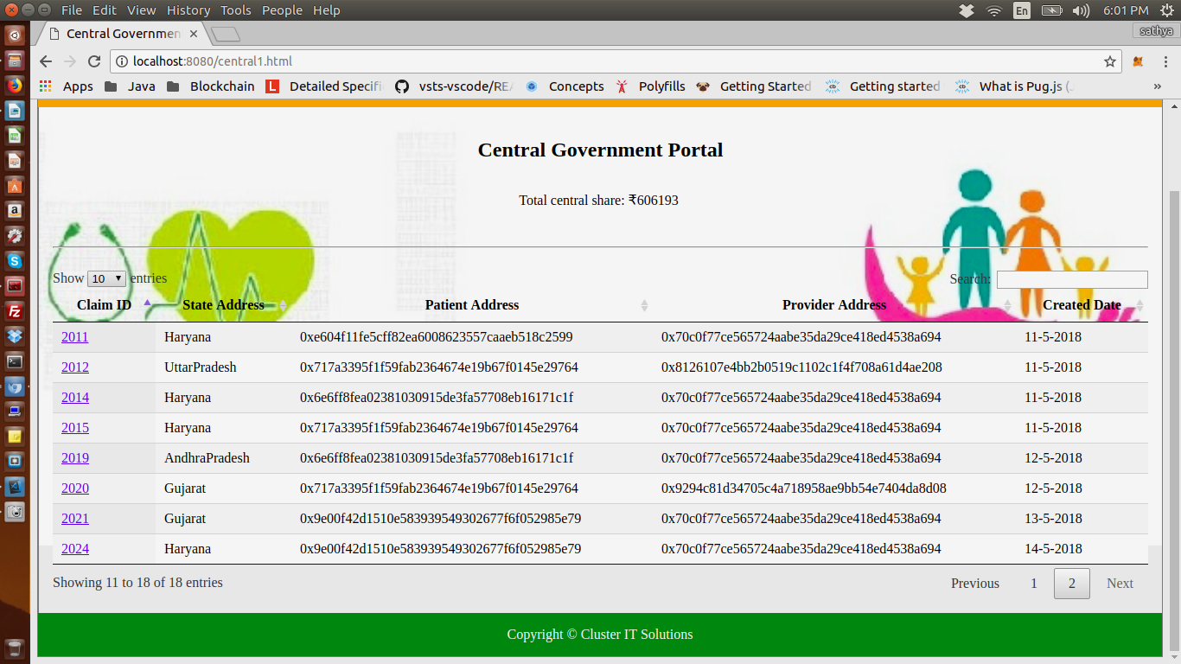

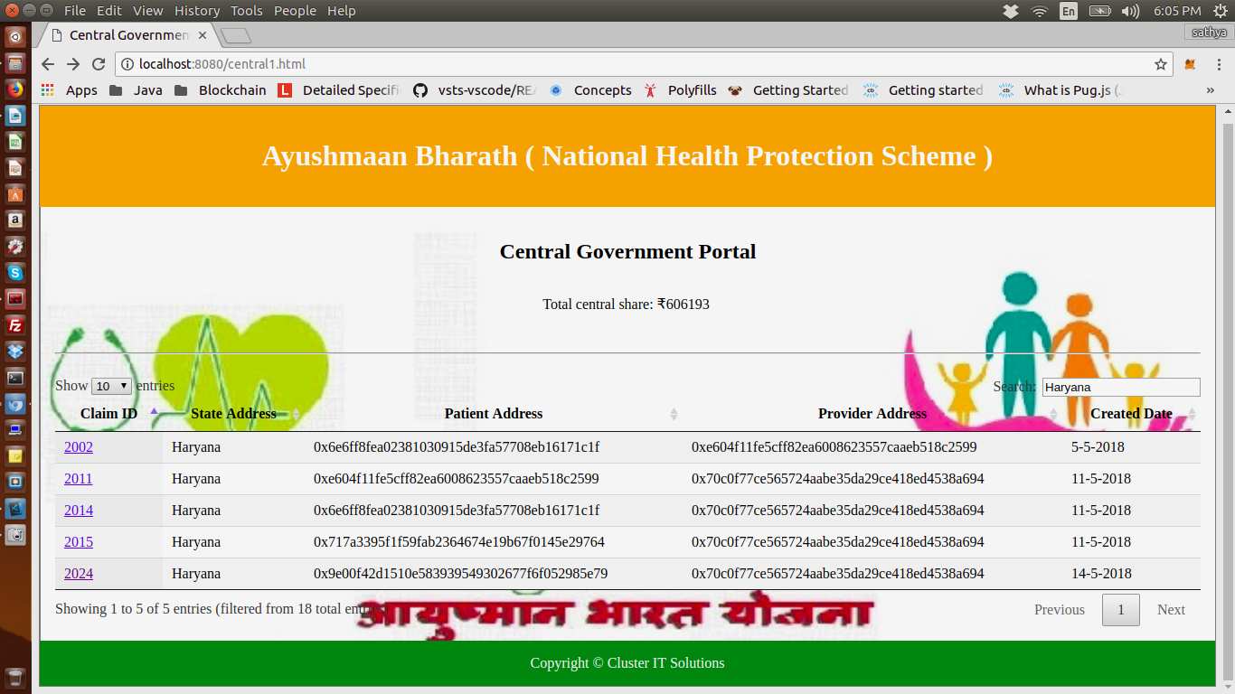

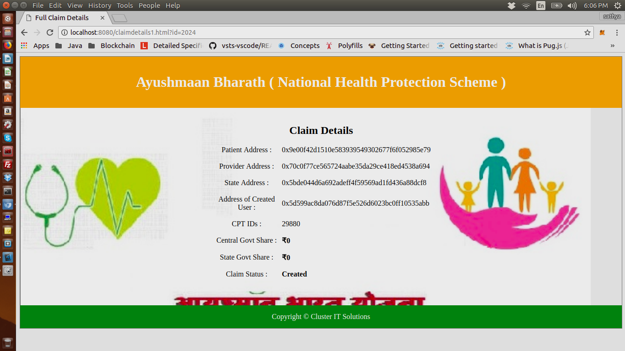

**State Government:**

- This user can view all the claims logged against this state and view the total state share.

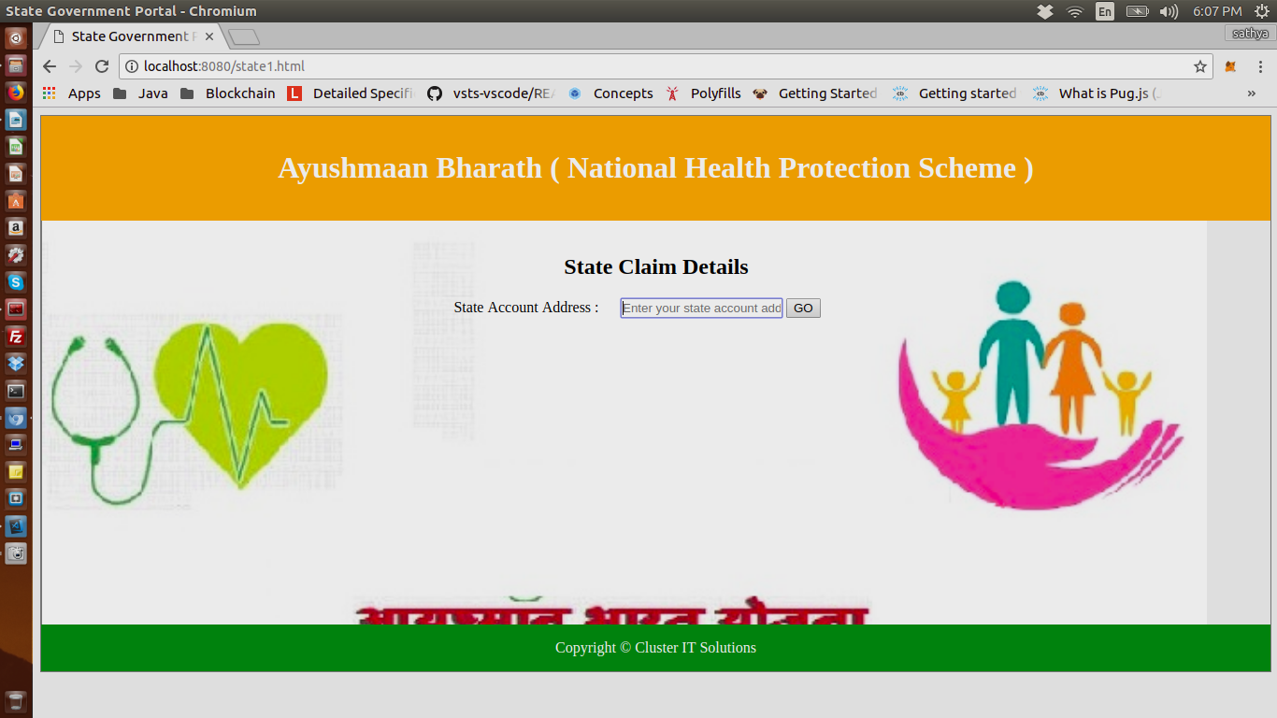

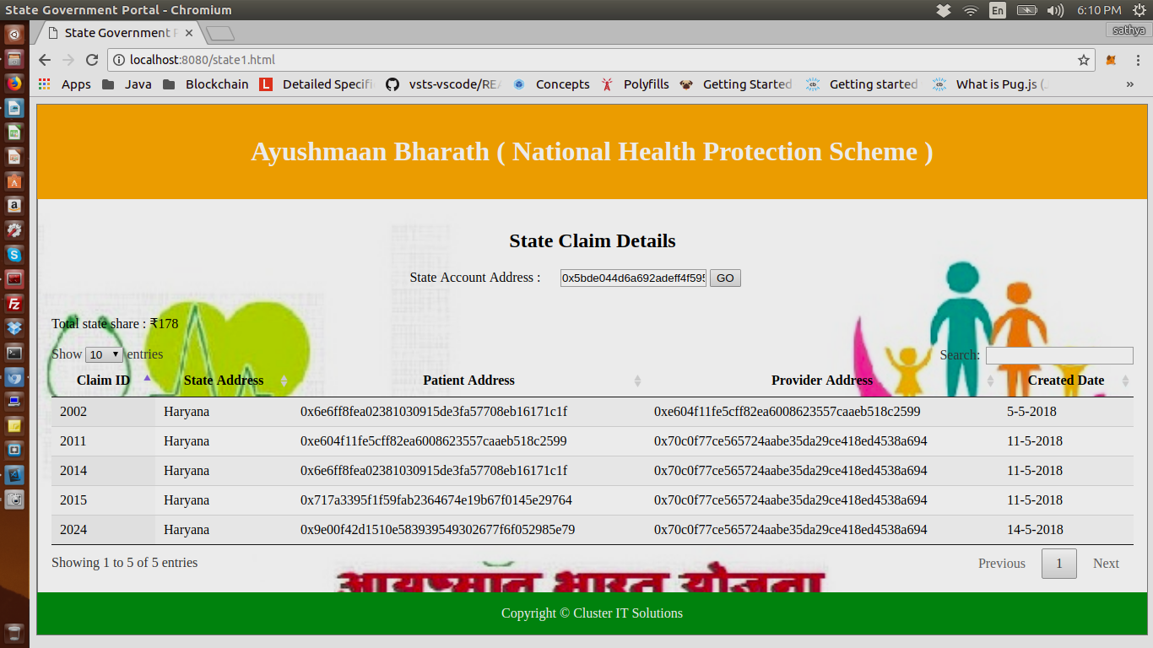

**Patient:**

- Patient can view all the claims logged against him/her.

- Needs to provide his/her acceptance by clicking on accept button for the claim in created status to

start claim process automatically.

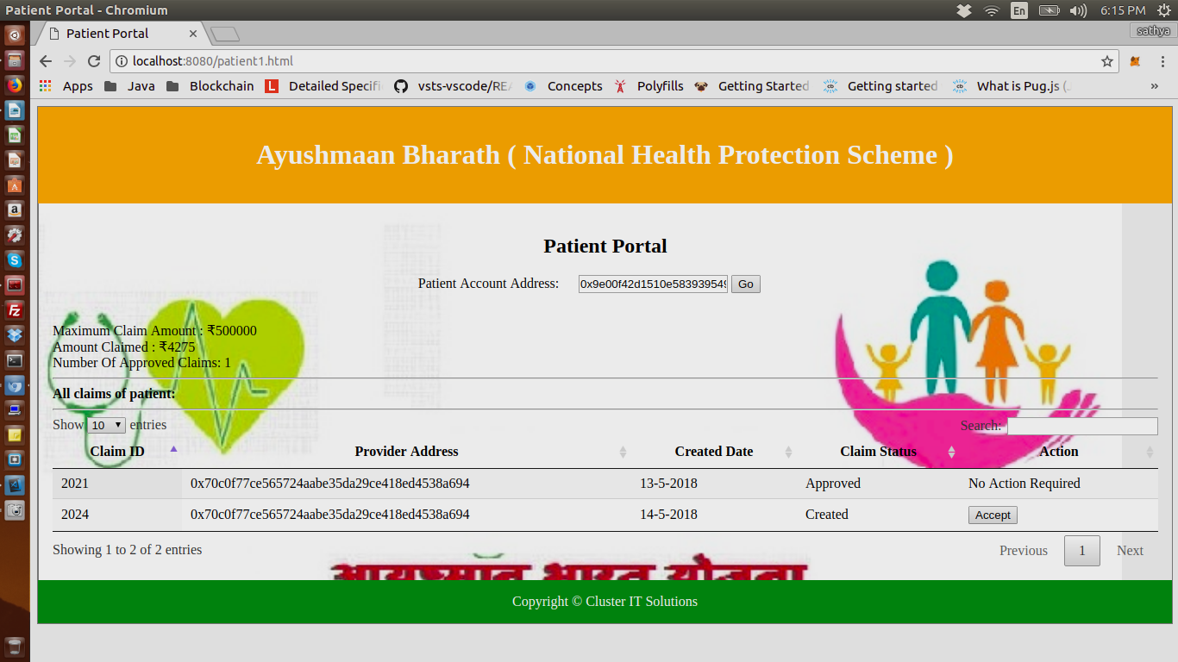

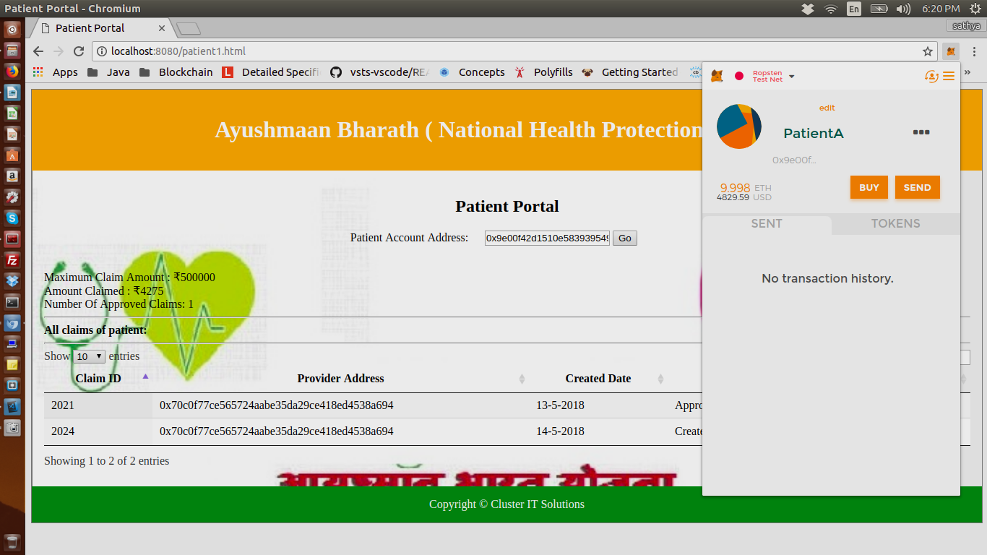

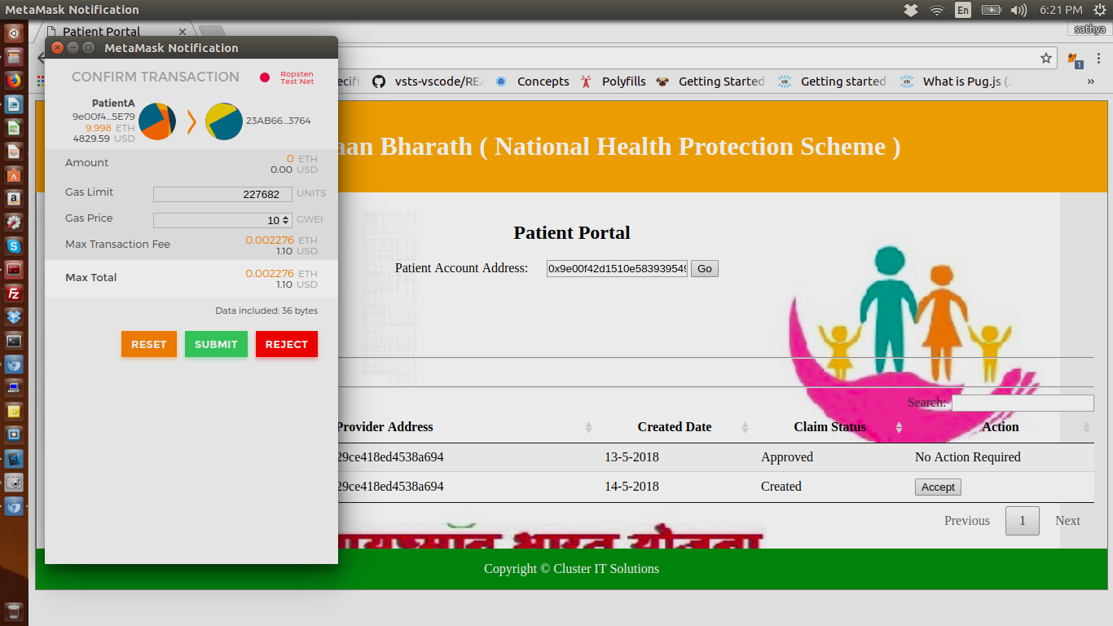

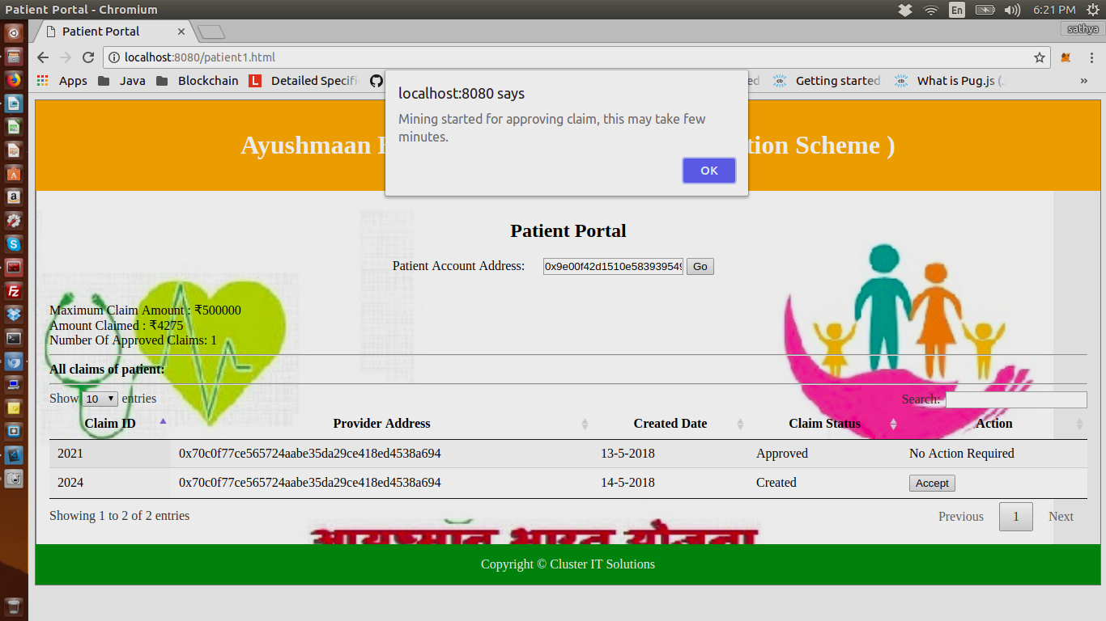

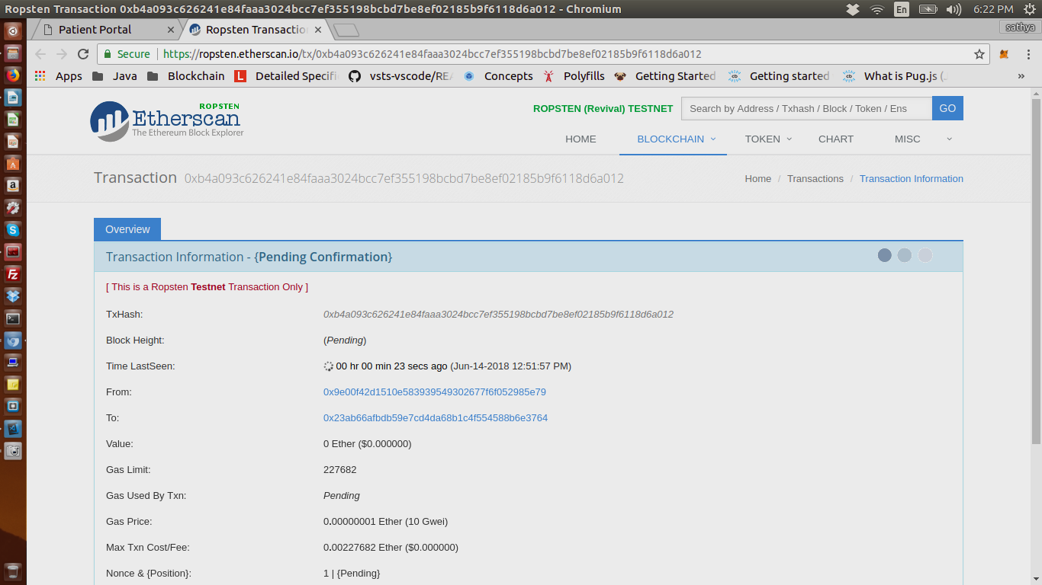

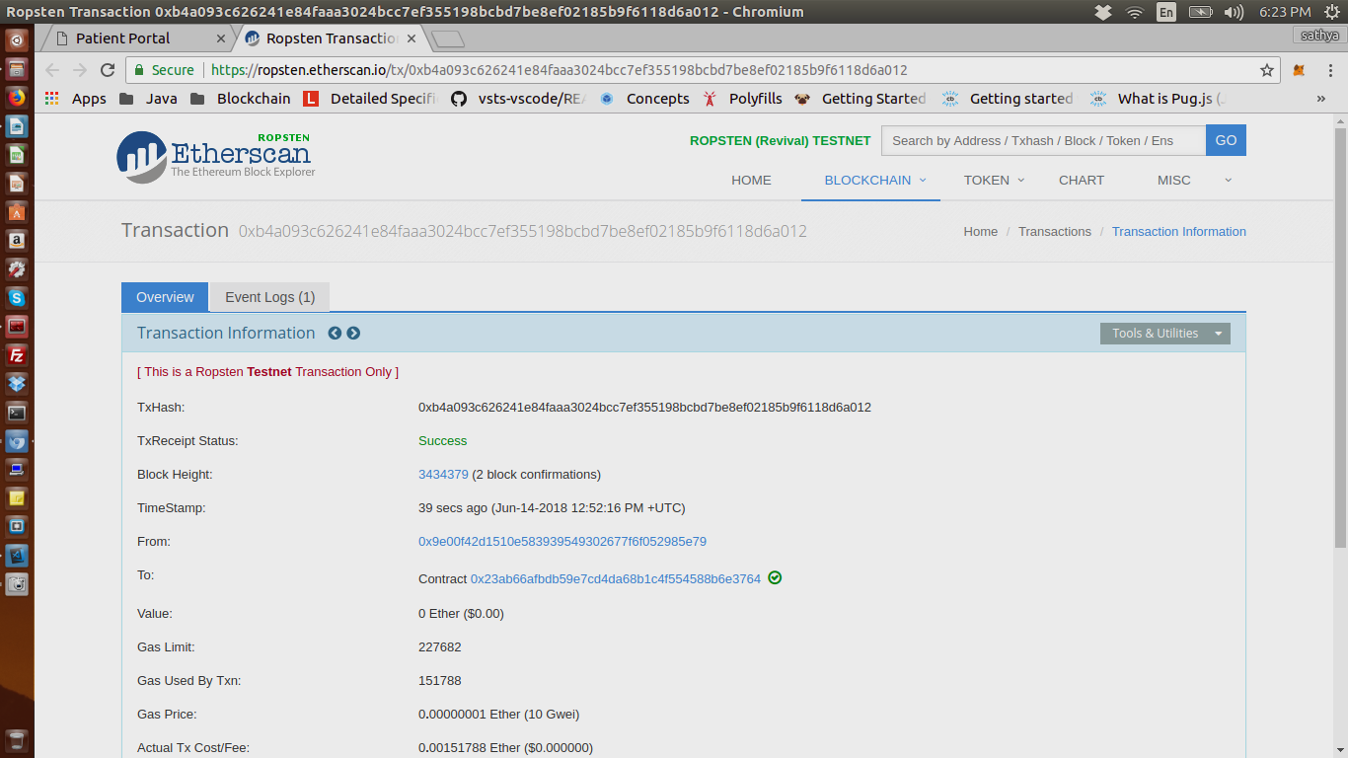

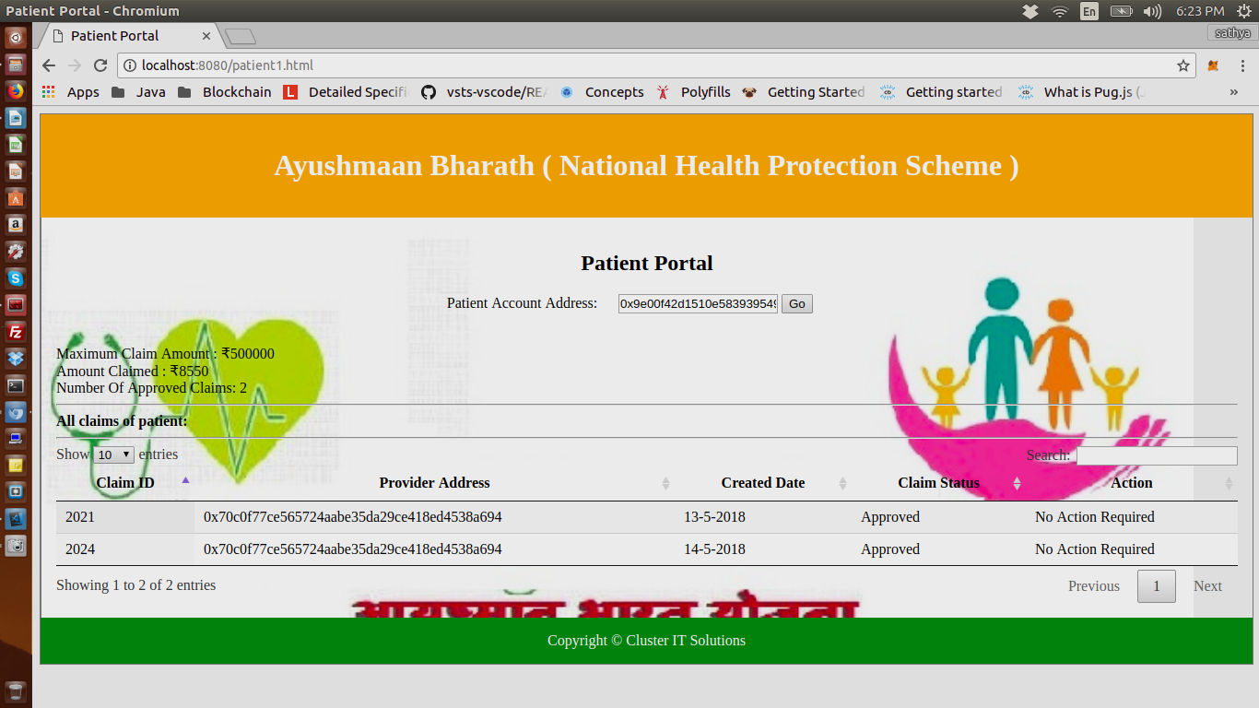

**BlockChain features covered by our PoC:**

[**Smart contract**](http://blockgeeks.com/guides/smart-contracts-the-blockchain-technology-that-will-replace-lawyers/)**:**

It is just a phrase used to describe computer code that can facilitate the exchange of money, content, property, shares, or anything of value. When running on the blockchain a smart contract becomes like a self-operating computer program that automatically executes when specific conditions are met. Because smart contracts run on the blockchain, they run exactly as programmed without any possibility of censorship, downtime, fraud or third party interference.

**Immutability:**

A third party cannot make any changes to data. Even if anyone trying to modify our smartcontract it will generate a new contract code. So, our smartcontract and its address and the data stored will not going to change.

**Corruption & tamper proof:**

Apps are based on a network formed around the principle of consensus, making censorship impossible. Our Dapp deployed to Ropten TestNet which uses Proof Of Work consensus for mining the transactions.

**Secure:**

With no central point of failure and secured using cryptography, applications are well protected against hacking attacks and fraudulent activities. In our Dapp all the addresses of stakeholders are in the form of cryptograpic notation.

As we initially registered providers and patients in the network. If we use unregistered addresses will throw an error and won’t allow transaction processing.

**Zero downtime:**

Apps never go down and can never be switched off.